**Memo**

To: Professor Pisano

From: Prithika Ganesh [pvganesh@bu.edu](mailto:pvganesh@bu.edu), Ignacio Nunez Gomez [inunezg@bu.edu](mailto:inunezg@bu.edu), Suyash Bhatia [suyashb@bu.edu](mailto:suyashb@bu.edu), Zen Mae Lee leezm@bu.edu

Team: Team 30, DevUp

Date: 30th April 2023

Subject: The Art of Valuation: Customer Installation Report

1. **Details of Customer Installation**

**2.0 List of All Requirements**

2.1 Modified Requirements for Original and Final Product

**3.0 Overall Testing Assessment**

3.1 Overall Assessment of First Product Installation Based on Requirements

3.2 Overall Assessment of Second Product Installation Based on Requirements

3.3 Follow Up Plans

**4.0 Customer Acceptance Letter**

**1. Details of Customer Installation**

The following are the details for the Customer Installation which took place via zoom. All members of the group were present to both demonstrations, and then observe the successful installation of the application on our client’s device.

First Installation Meeting:

1. **Date:** 25th May, 2023
2. **Place:** Virtual Zoom Meeting
3. **Members Present:** Prithika Ganesh, Ignacio Nunez Gomez, Suyash Bhatia, Zen Mae Lee
4. **Customers Present:** Brendan Cahill

Second Installation Meeting:

1. **Date:** 27th May, 2023
2. **Place:** Virtual Zoom Meeting
3. **Members Present:** Prithika Ganesh, Ignacio Nunez Gomez, Suyash Bhatia, Zen Mae Lee
4. **Customers Present:** Brendan Cahill

**2. List of All Requirements**

2.1 Modified Requirements for Original and Final Product

The original scope of Workshop Finance was very ambitious, and included stretch goals of a functional recommendation engine and a file sharing system. One of the most significant changes to the scope was going from an Android and iOS compatible application to solely an iOS application due to the limitations of ReactNative, and time and resource constraints. We diverted most of our energy into the basic functionality of the application (i.e. making valuations and visualizing it on the football field). While the fundamental goals of the Workshop Finance project were achieved, the stretch goals were not able to be fulfilled. Attached below are the initial requirements for the project if the current requirements were fulfilled.

*Table 2.1: Table of Features Fulfilled From Our Customer Installation, Stretch Goals Noted By \**

| *Feature* | *Objectives* | *Functions* | *Constraints* | *Fulfilled?* |
| --- | --- | --- | --- | --- |
| User Experience | For the app to run smoothly and reliably produce visuals and results. | Efficiently generate view of valuations with quick data fetching facilitated by an optimized backend. Ideal page load time of <3 seconds [5]. | Team’s limited knowledge on UX development. | Y |
| User Interface | Enable users to control the application and view the football field graphics. | Include basic navigation features and a holistic range of levers for the user to customize their valuations; functional scope of application to have ~70 elements e.g. “Add New Valuation” and “Change Target”. | Team’s limited knowledge on UI development. | Y |
| Local Data Storage | To preserve user search and valuation history to be retrieved when the user returns to application after use. | Store user data locally on the device to provide users with an instant startup experience. Productivity apps on iOS typically take up about ~400MB of space e.g. Excel [6]. | Limited to device storage application is operating on. | Y |
| Computation Engine | Reduce workload on the frontend to reduce storage load on the device. | Define the frontend payload to perform actions such as users changing their valuation criteria. | Running several calculations can be computationally intensive. | Y |
| API Integration | To minimize use of local storage and allow users to efficiently access a wide range of updated market data for valuations. | Implement API optimization techniques such as caching and ensuring sufficient cloud infrastructure. | Limited by the abilities of the API used and the amount of cloud storage available. | Y |
| Identity Service | To have safe, synchronous multi-user access for customers. | Authenticate user profiles for each user logging into the application and keep user information confidential. | Team’s limited knowledge on cybersecurity; may encounter data leaks. | Y |
| Market Database | To reliably and efficiently fetch data from the market database (i.e. based on the date the user chooses). | Employ a range of third-party databases to be accessed through APIs with a daily refresh rate. | Limited by financial resources and the magnitude of data needed. | Y |
| Cloud-based Hosting | Scalable access to computing resources for the functioning of the application. | Employing advanced, reliable cloud services such as IEX. | Limited by financial resources. | Y |
| Football Field Sharing System* | A user can share viewing and editing privileges of a created football field graph with another user across the app. | Share football field charts with other users on Workshop Finance. | Limited by knowledge of security protections for sharing private data across database | N |
| File Exporting System* | A user can export a created Football Field in a JPEG format, allowing them to share it over via email or social media. | Users are able to export football field charts in the form of JPEG files for external use. | Limited knowledge of converting visuals to pdf format and integrating third party file sharing systems. | N |
| Recommendation Engine* | To provide a personalized user experience and buffer as a user searches for a company to value. | Using machine learning models such as clustering on a range of user inputs over time. | Limited by the capabilities of the ML model chosen to deploy. | N |

**3. Overall Testing Assessment**

3.1 Overall Assessment of First Product Installation Testing Based on Requirements

Given the close hands-on relationship with the client throughout the development and testing process, and constant communication and progress report meetings, the client was satisfied with the final product during the installation. As the client was given regular updates throughout the development process, he was able to give immediate feedback about different design and implementation methods.

Therefore, when it came to final customer installation, the team presented the final working app on our phones and the emulator. We then sent the client the Github repository, and had the client privately copy the repository to their local account. We then explained to the client how to run the applications. To do this, the client first downloaded the Expo Go app on his smartphone. We then had the client open an IDE, sign into Github and pull their copy of the workshop finance repository. We had the client manually update the ip address calls in the application to his local ip address. We then had him navigate to the backend folder, and then run the py.routes file to run the backend local server. We then had him navigate to the frontend folder and then run the app with the “npm start” command. He then scanned the QR code, and was able to run the app on his mobile device through Expo Go.

The client played around with different aspects of the app, testing its anticipated user-error functionalities, as well as its normal use cases. The client also created an account, and was able to sign in and out of the app multiple times successfully, and generate multiple different football field valuations. Overall, the client was very happy with the final app and its installation. The only feedback the client had was that it was a bit tedious for him to manually change the ip address during start up, and he therefore asked if the team was able to automate that process. The team agreed to do so and follow up with him in a couple of days.

3.2 Overall Assessment of Second Product Installation Testing Based on Requirements

Given the feedback of the client desiring an automated ip retrieval system, so the final product could be run on any computer with little technical knowledge, the team was able to implement that process successfully. The team met with the client for a final time and had the client pull the updated code from his private github repository. The client was now simply able to navigate to the backend and run the local server, and navigate to the frontend and run the frontend application successfully. The client was satisfied with the final result.

3.3 Follow Up Plans

As the senior design capstone project concludes with ECE Day on May 5th, 2023, the team plans to cease all frontend and backend development on the project. As shown in Section 2, the full potential of the application includes a recommendation engine for companies to be added as comps and additional football field functionalities such as exporting the football field as a JPEG file or sharing with other users. Because the MVP/current state of Workshop Finance does not have these features, this shows that there is still a lot that can be done to the application for future developers to take on and further enhance the application. Future follow ups with the client will potentially be mainly for any queries on the code that was handed over.

**4. Customer Acceptance Letter**

The customer installation of Workshop Finance was formalized via a PDF project acceptance letter shown below.

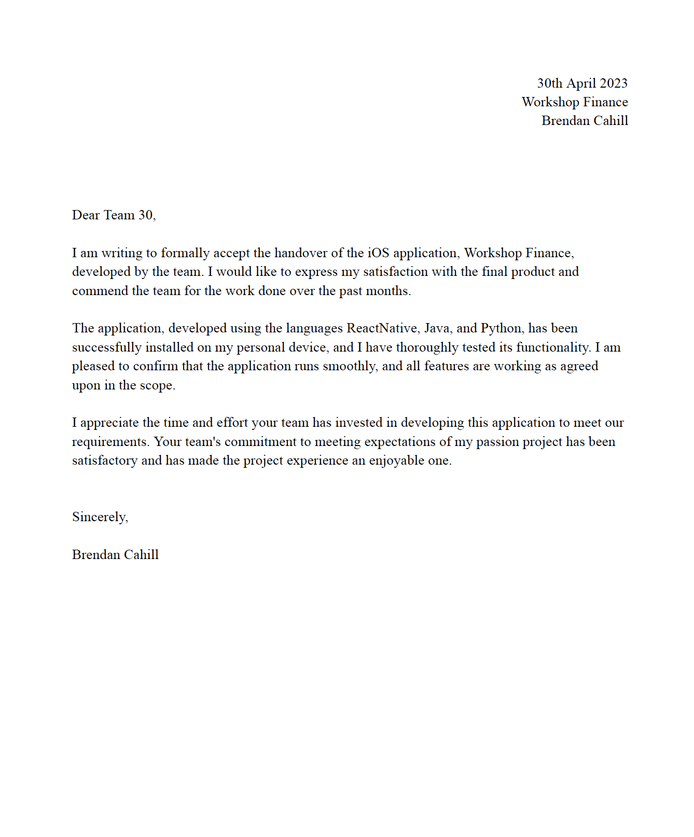

*Figure 4.1: Customer Acceptance Letter of Workshop Finance.*